Convert Decimals to Percents
Quick Method: move the decimal point 2 places to the right and add a "%" sign!

Example: Convert 0.35 to percent
Move the decimal point two places to the right: 0.35 → 3.5 → 35.
Add a % sign: 35%
Answer 0.35 = 35%

Converting From Decimal to Percent
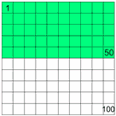

In this box 50 of the 100 squares are green, so ⁵⁰/₁₀₀ , or 0.5 of the box is green.
Percentage means "per 100", so 50% of the box is green.
So 0.5 (a decimal number) = 50%

(the "%" tells you that there is a hidden "/100" there)

To convert from decimal to percentage, multiply the decimal by 100, but remember to put the "%" sign so people know it is per 100.

The Easy Way
The easy way to multiply by 100 is to move the decimal point 2 places to the right. so:
From Decimal | To Percent
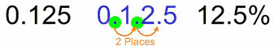 |  | move the decimal point 2 places to the right, and add the "%" sign.

Example: Convert 0.68 to percent
Move the decimal point two places to the right: 0.68 → 6.8 → 68.
Answer 0.68 = 68%

You may also need to add zeros on the right in order to move the decimal point:

Example: Convert 1.2 to percent
Move the decimal point two places to the right: 1.2 → 12. → 120.
Answer 1.2 = 120%

