Convert Percents to Decimals
Just move the decimal point 2 places to the left and remove the "%" sign!

Converting From Percent to Decimal
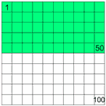
Percent means "per 100", so 50% means 50 per 100, or simply ⁵⁰/₁₀₀
If you divide 50 by 100 you get 0.5 (a decimal number).
So, to convert from percent to decimal: divide by 100, and remove the "%" sign.

The Easy Way
The easy way to divide by 100 is to move the decimal point 2 places to the left, so
From Percent | To Decimal
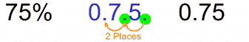 |  | move the decimal point 2 places to the left, and remove the "%" sign.

Example: Convert 8.5% to decimal
Move the decimal point two places to the left: 8.5 -> 0.85 -> 0.085
Answer 8.5% = 0.085

